EDUCATIONAL ORGANISATION USING SERVICENOW
CATEGORY: ServiceNow System Administartor


➢ TEAM ID :NM2025TNID02691
➢ TEAM SIZE : 5
➢ TEAM LEADER : GANESH S
➢ TEAM MEMBER : SRINITHIKETHAN G
➢ TEAM MEMBER : DEEPAK K
➢ TEAM MEMBER : SAKTHI C
➢ TEAM MEMBER : CHANDRU J
Project Description:
→The Educational Management System is a comprehensive platform designed to streamline administrative tasks within educational institutions. It facilitates efficient management of student and teacher data, simplifies the admission process, and provides tools for monitoring student progress.

PHASE -1

Ideation Phase
Brainstorm & Idea Prioritization Template

Date | 04 November 2025
Team ID | D6FF0253C2B7F5DACC64A29FAD060D50
Project Name | Educational Organisation Using ServiceNow
Maximum Marks | 4 Marks
What is School Brainstorming?
Brainstorming: Creating Amazing ServiceNow Ideas!
Brainstorming is like having a free and open idea party that encourages everyone—students, teachers, and the IT team—to join in the creative thinking! This process leads directly to solving the service problems the school faces.
The Golden Rules for Great Ideas:
  Rule
  Volume Over Value
  Out-of-theBox
  What it Means for Our ServiceNow Project
  Throw out TONS of ideas (volume) first! Don't worry if they are good or bad yet (value). We want quantity!
  Wild and unique ideas are WELCOME! Maybe the school needs a "Help Robot" or a special app that sings when your request is finished! No idea is too silly to start with.
  Collaborate and Build
  Everyone is encouraged to work together and help each other make their ideas even better. If one person suggests a "Help Button," another person can build on it by suggesting the "Help Button glows green when it's done!"
Using the Idea Template
In Our team has use a template (like a digital whiteboard or a piece of paper) in our brainstorming sessions to quickly unleash your imagination and start shaping concepts. Even if the students, teachers, and IT team aren't sitting in the same room, this shared space helps everyone collaborate to develop a rich amount of creative solutions for the ServiceNow platform!
Ref Link:
https://app.mural.co/t/educationalorganisationusing8461/m/educationalorganisationusing8461/17618 00598369/5ac1a0381aa83168c8e1e85848d5e148a6f34335
Step-1: Team Gathering, Collaboration and Select the Problem Statement

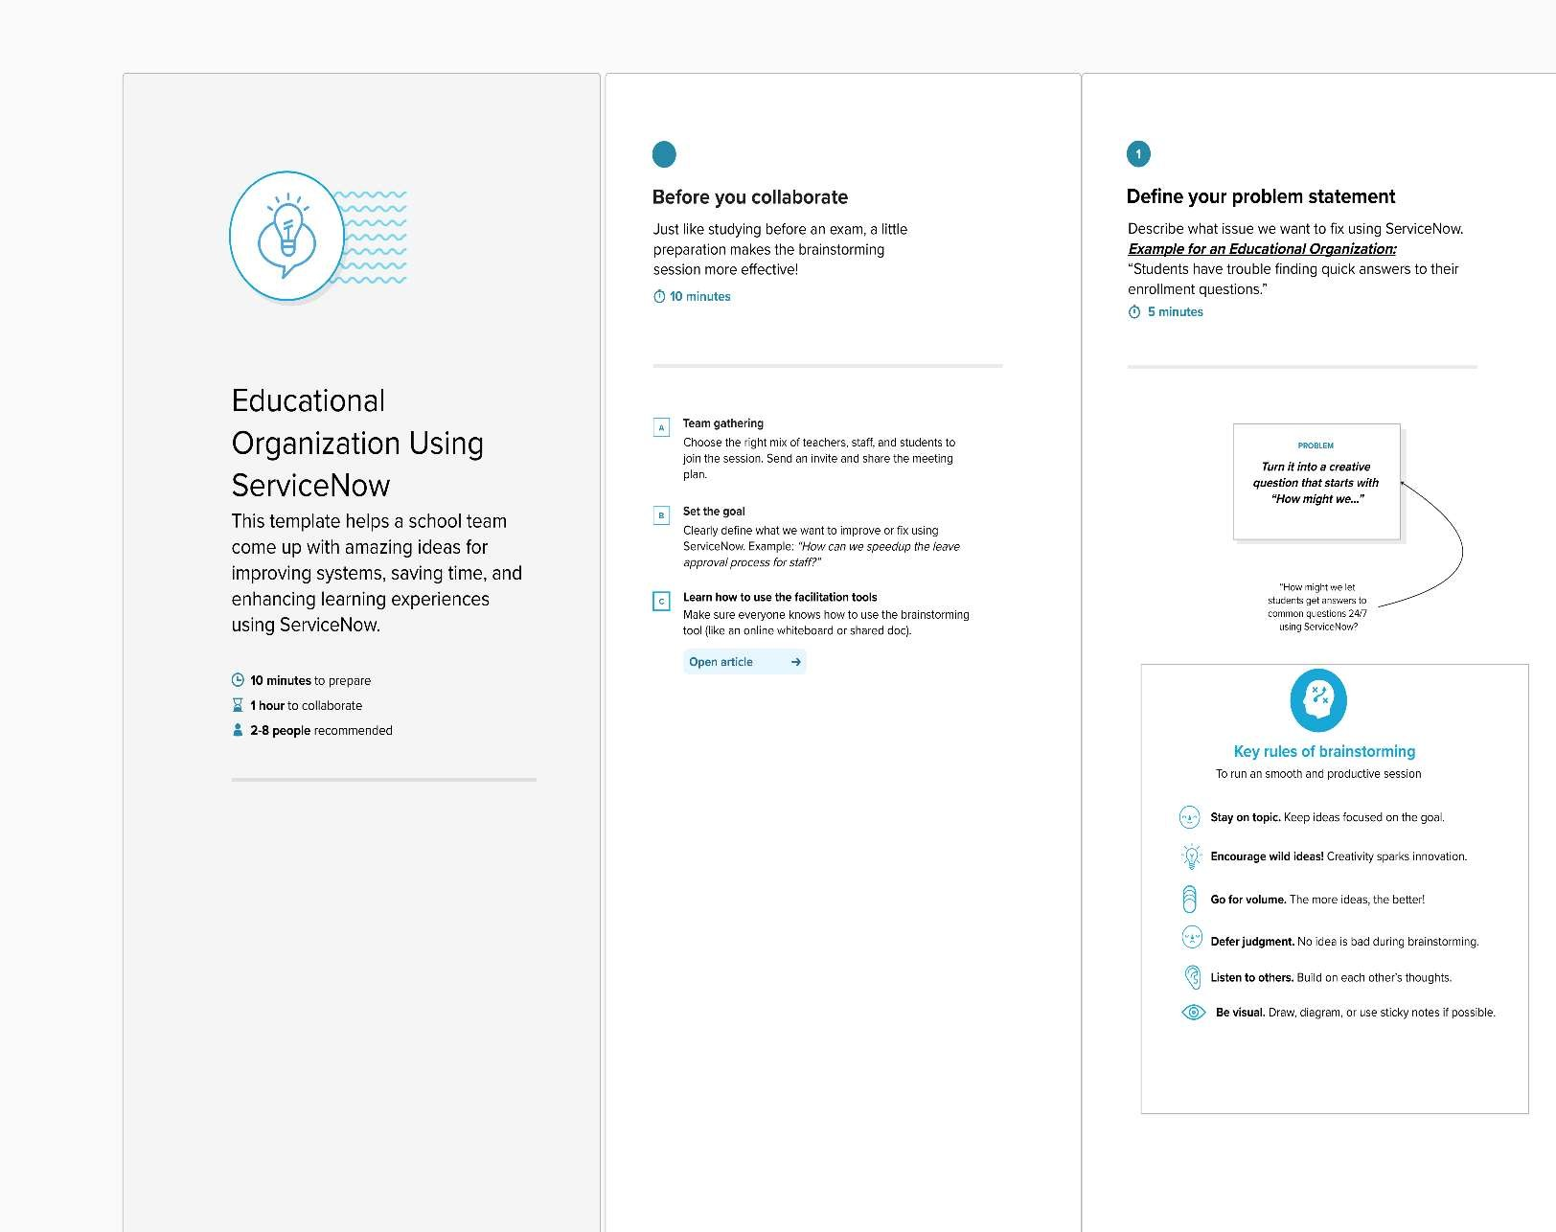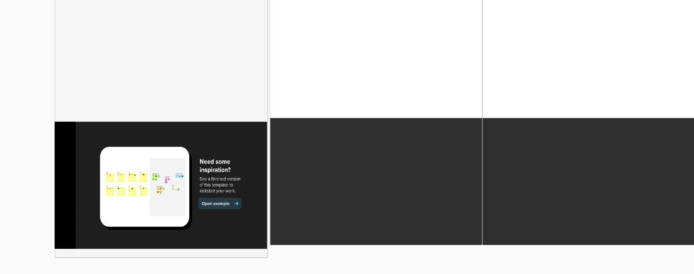
Step-2: Brainstorm, Idea Listing and Grouping

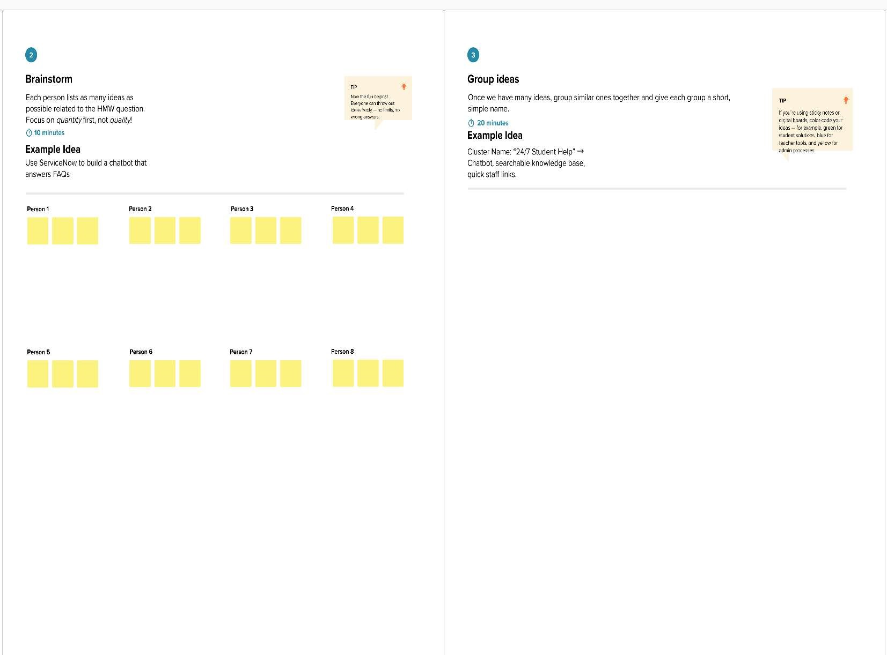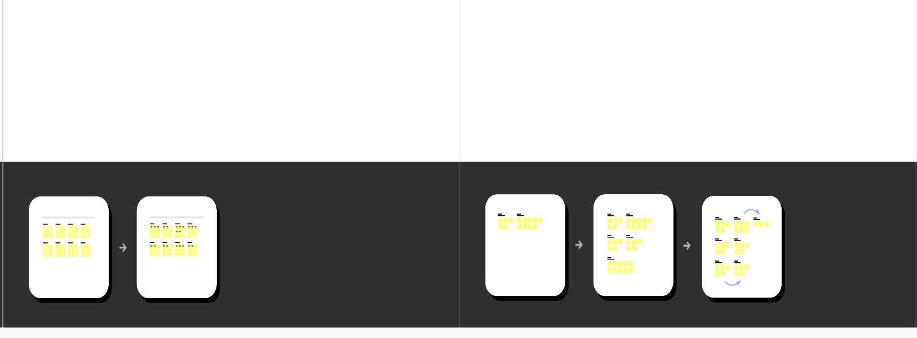
Step-3: Idea Prioritization

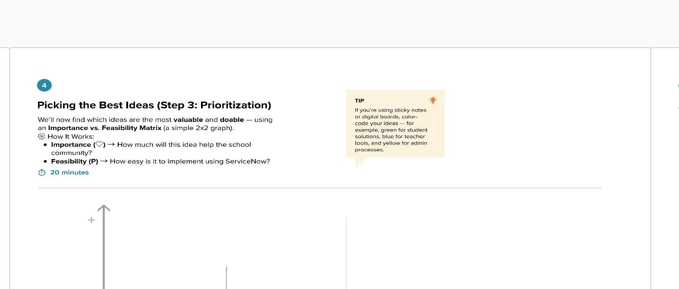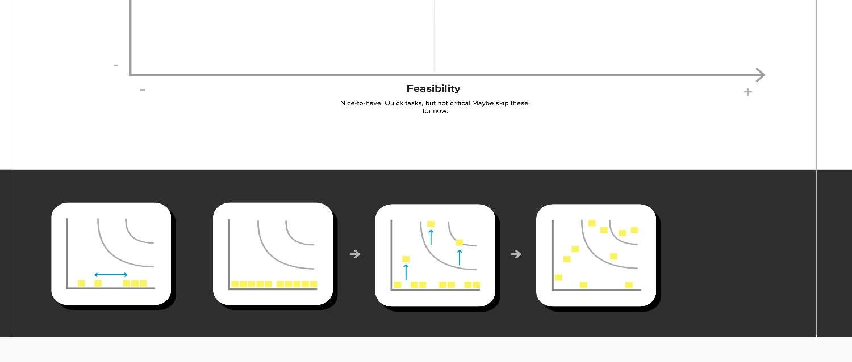

PHASE -2

Ideation Phase
Define the Problem Statements

Date | 04 November 2025
Team ID | D6FF0253C2B7F5DACC64A29FAD060D50
Project Name | Educational Organisation Using ServiceNow
Maximum Marks | 2 Marks
The ServiceNow Problem Sentence: Educational Organisation Using ServiceNow
→The goal of this Problem Statement Template is to help the school truly understand things from a student's or teacher's point of view!
  Goal
  Understand the User
  Focus on What Matters
  Find the Ideal Solution
  Empathize
  Simple Explanation for the School
  We use this special problem sentence to look at things from a student's or teacher's point of view!
  This template helps the school know exactly what matters most so they can build the ServiceNow systems that everyone will love to use.
  When the problem sentence is clear and strong, it helps the school's team find the perfect solution using ServiceNow to fix the challenges students and teachers face.
  It also helps everyone feel what the student or teacher feels (empathize), so they understand how the school's services (like getting a new laptop or ordering supplies) look from the user's side.

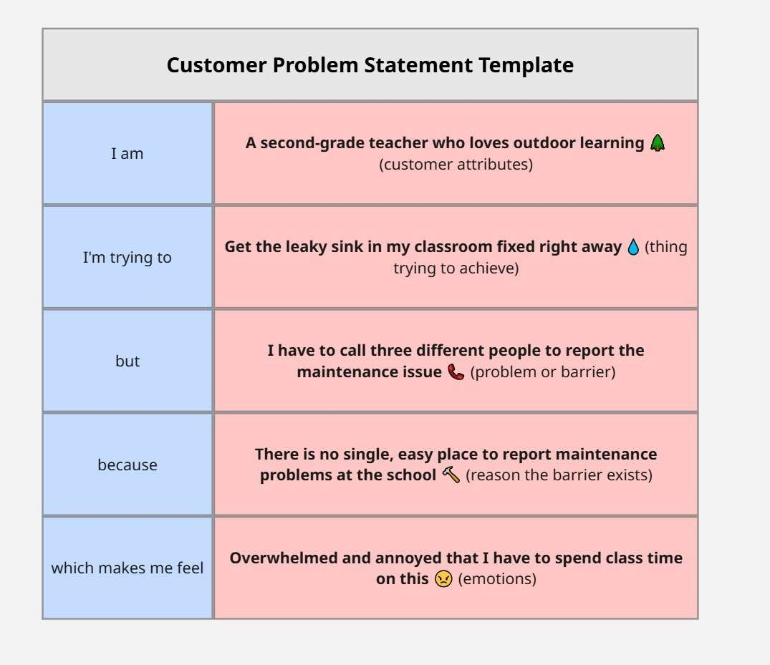
Ref Link: https://miro.com/app/board/uXjVJyK2Lbw=/ Example:
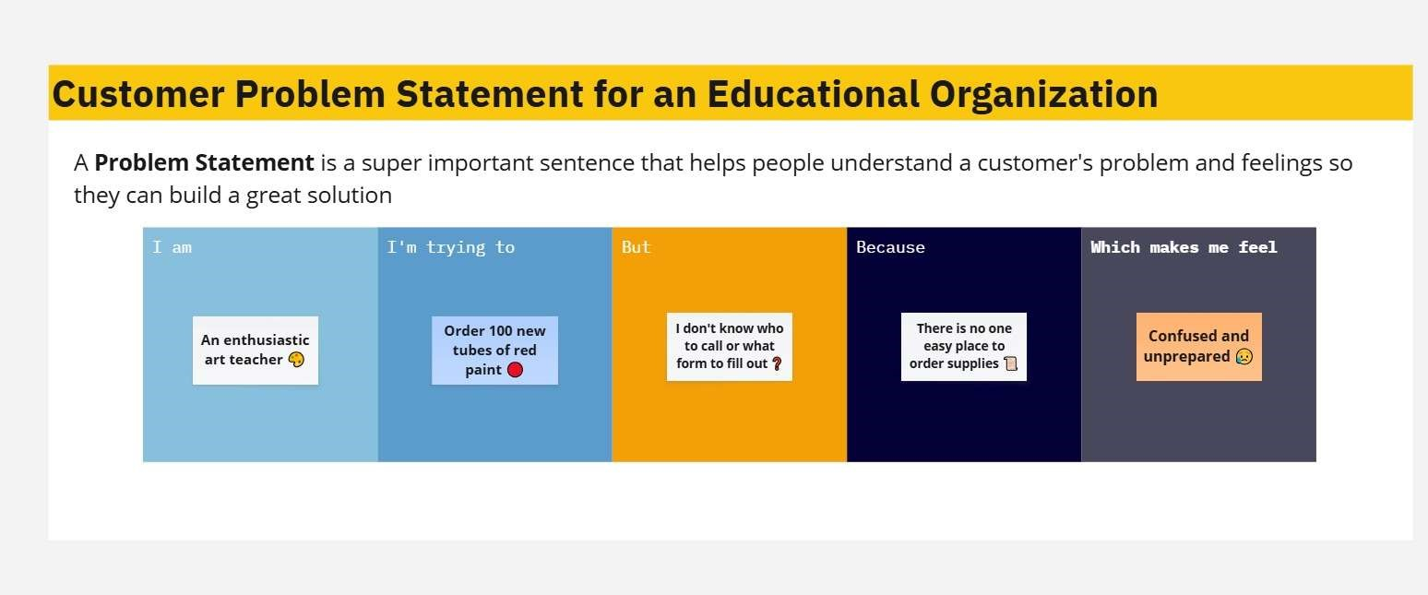

PS(problem statement) | I am  (Customer) | I'm trying to | But | Because | Which makes me feel
PS-1  (Student IT) | A motivated 5th-grade student | Finish my big science project | The school's laptop keeps freezing | The laptop is very old and needs new software | Stressed and like I might fail
PS-2  (Teacher  Supplies) | An enthusiastic  art teacher | Order 100 new tubes  of red  paint | I don't know who to call  or what  form to fill out ❓ | There is no one easy place to order supplies | Confused and unprepared

PHASE -3

Ideation Phase
Empathize & Discover
Empathy Map Canvas: Educational Organisation Using ServiceNow
Date | 04 November 2025
Team ID | D6FF0253C2B7F5DACC64A29FAD060D50
Project Name | Educational Organisation Using ServiceNow
Maximum Marks | 4 Marks
The Tool: Empathy Map:
An Empathy Map is a simple, easy-to-digest visual that captures knowledge about a user’s behaviors and attitudes. It helps teams better understand their users and consider things from the user’s perspective, including their goals and challenge.
The User: A High School Teacher
Let's use the Empathy Map to understand a High School Teacher who needs support services (like IT help or ordering textbooks) from the school's new ServiceNow system.
I. Understanding the User's World, II. The Bottom Line: Pain & Gain
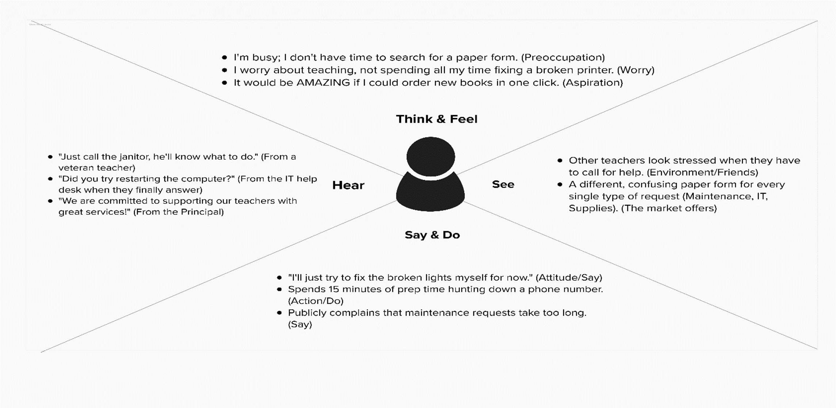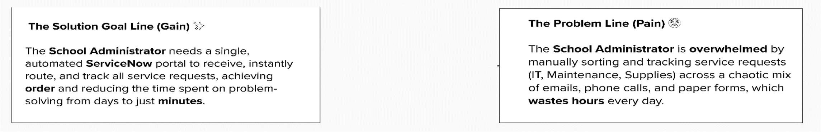
Ref Link:
https://app.mural.co/t/educationalorganisationusing8461/m/educationalorganisationusing8461/1761821334 070/93ba8f19f75d594a13e1a18fd29416ef27726a93?sender=u90fc56cc1940579346736523 Example: The User: A School Administrator :
